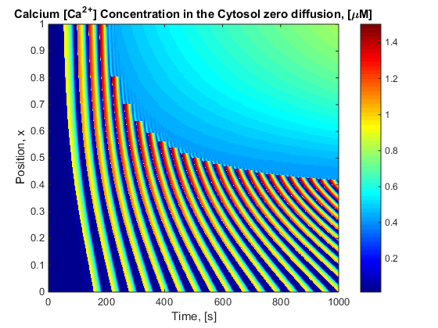 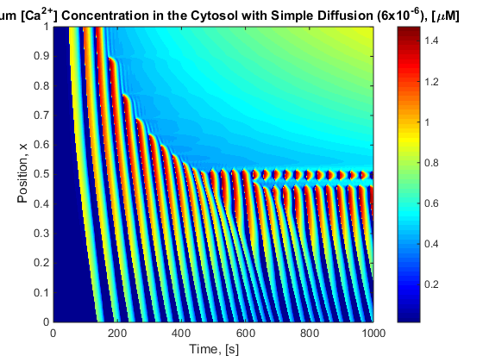

Sneyd Model

%% Varriable constants

malpha = 0; % Ip3 Dynamics turned off.

mdelta = 1; % Delta is 0 means it is a closed cell model

%% Constants

K_a = 0.227;

K_p = 0.3;

K_s = 0.1;

K_pm = 0.12;

K_PLC = 0.16;

K_i = 0.1;

K_IPR = 2;

K = 2.13e-5;

V_s = 0.9;

V_pm = 0.01;

V_PLC = 2;

V_deg = 0.66;

mgamma = 0.185;

tou_h = 12.5;

v_0 = 0.004; %%%%%%%%% RUA EDIT

v_1 = mbeta*0.004;%*0 + 0.045;

%% Calculations

c_e = (Ct-C)/mgamma;

h_inf = (K_i.^2./(K_i.^2 + C.^2));

%% Fluxes

J_ipr = K_IPR*(C.^3./(K_a^3 + C.^3)).*(P.^2./(K_p^2 + P.^2)).*H;

J_serca = V_s* (C.^2 - K*c_e.^2)./(K_s^2+C.^2);

J_in = v_0+v_1.*P ;

J_pm = V_pm*(C.^2./(K_pm^2+C.^2));

%% Differential Equations

L_C = (c_e-C).*J_ipr - J_serca + mdelta*(J_in - J_pm);

L_Ct = mdelta*(J_in - J_pm);

L_P = V_PLC*((1-malpha)*K_PLC^2 + C.^2)./(K_PLC^2 + C.^2) - V_deg*P;

% L_H = (1/tou_h).*(h_inf-H)./(h_inf);

L_H = (1/tou_h).*(h_inf-H);